**East West University**

**Department of Computer Science & Engineering**

**A/2, Jahurul Islam Avenue, Jahurul Islam City, Aftabnagar, Dhaka-1212**

______________________________________________________________________

**Lab Manual : 02**

**Course Code : CSE207**

**Course Title : Data Structures**

**Instructor : Md. Manowarul Islam, Adjunct Faculty, Department of CSE**

**Objective:**

The objective of this lab is to provide a fundamental idea about the sorting element of an integer array using C programming. At the end of the lab, students are able to know:

* How to take input into an array.
* How to sort the element of the array.

**Exercise 1**

We can add, subtract, multiply and divide 2 matrices. To do so, we are taking input from the user for row number, column number, first matrix elements and second matrix elements. Then we are performing any of the operations on the matrices entered by the user. Take the choice from user and show the results accordingly.

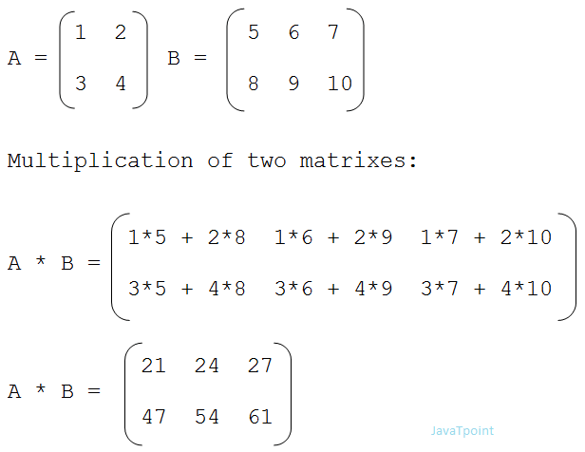



|  |  |
| --- | --- |
| **Sample Input** | **Sample Output** |
| Enter your choice:  1 for addition  2 for subtraction  3 for multiplication  3  Enter the first matrix:  1 1 1  2 2 2  3 3 3  Enter the second matrix  1 1 1  2 2 2  3 3 3 | You choose 3  Multiplication:  6 6 6  12 12 12  18 18 18 |

**Exercise 2**

Write a C program to read elements in a matrix and find the sum of elements of each row and columns of matrix. C program to calculate sum of rows and columns of matrix.

**Example**: If elements of matrix are:

1 2 3

4 5 6

7 8 9

Output:

Sum of rows:

Row 1: 6

Row 2: 15

Row 3: 24

Sum of columns:

Column 1: 12

Column 2: 15

Column 3: 18

**Exercise 3**

Write a C program to read elements in a matrix and find the maximum element in each row and column of the matrix.

**Example:**

If the elements of the matrix are:

1 2 3

4 5 6

7 8 9

Matrix:

1 2 3

4 5 6

7 8 9

Maximum elements:

Row 1: 3

Row 2: 6

Row 3: 9

Column 1: 7

Column 2: 8

Column 3: 9

**Exercise 4**

Write a C program to read elements in one matrix and transpose it.

**Example:**

If matrix =

1 2 3

4 5 6

7 8 9

transpose of the matrix =

1 4 7

2 5 8

3 6 9

**Exercise 5**

Write a C program to read elements in one matrix and show the diagonal of it.

**Example:**

If matrix =

1 2 3

4 5 6

7 8 9

Diagonal of the matrix =

1

5

9

**Exercise 6**

Write a C program to check whether a matrix is an identity matrix or not.

**Example:**

Enter the elements of the matrix

1 0 0

0 1 0

0 0 1

**Output**

It is an IDENTITY MATRIX